1 | Title: Program to simulate Simple Reflex Agent for detecting source of water leakage in a house

Theory:
A Simple Reflex Agent is a type of artificial intelligence agent that makes decisions based on the current perceived state of the environment, without considering past states or future consequences. In this case, we're using a simple reflex agent to detect the source of water leakage in a house.
The agent uses a set of predefined rules to determine the source of the leak based on sensor inputs. These sensors detect wetness in different areas of the house (hall, kitchen, bathroom) and the state of the window (open/closed) and whether it's raining.
The rules for our agent are:
- If the hall is wet and the kitchen is dry, then there's a leak in the bathroom.
- If the hall is wet and the bathroom is dry, then there's a problem in the kitchen.
- If the window is closed or it's not raining, then it's confirmed that water is not from outside.
- If there's no water from outside and the problem is in the kitchen, then the leak is in the kitchen.

Code:
def detect_leak(hall_wet, kitchen_wet, bathroom_wet, window_closed, raining):
if hall_wet and not kitchen_wet:
return "Leak in bathroom"
elif hall_wet and not bathroom_wet:
return "Problem in kitchen"
elif window_closed or not raining:
if kitchen_wet:
return "Leak in kitchen"
else:
return "No leak detected"
else:
return "Water might be coming from outside"

hall_wet = input("Is the hall wet? (yes/no): ").lower() == 'yes'
kitchen_wet = input("Is the kitchen wet? (yes/no): ").lower() == 'yes'
bathroom_wet = input("Is the bathroom wet? (yes/no): ").lower() == 'yes'
window_closed = input("Is the window closed? (yes/no): ").lower() == 'yes'
raining = input("Is it raining? (yes/no): ").lower() == 'yes'

#run agent
result = detect_leak(hall_wet, kitchen_wet, bathroom_wet, window_closed, raining)

print("\\nAgent's conclusion:", result)

print("\\nLab No.:1")
print("Name:Samir Paudel ")
print("Roll No./Section: 114/D ")

Output:

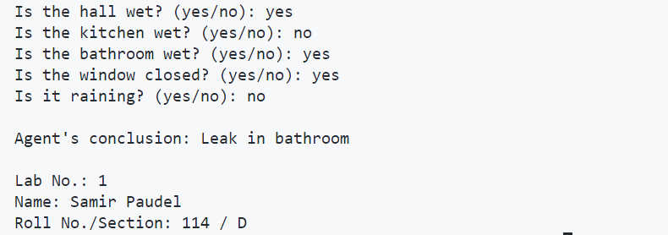

2 | Title: WAP to implement BFS for a graph

Theory:
Breadth-First Search (BFS) is a graph traversal algorithm that explores all the vertices of a graph or tree at the present depth before moving on to the vertices at the next depth level. It uses a queue data structure to keep track of the vertices to be explored next.
BFS is particularly useful for finding the shortest path between two vertices in an unweighted graph, as it explores vertices in order of their distance from the starting vertex.

Key characteristics of BFS:
- Completeness: BFS is complete, meaning it will find a solution if one exists.
- Optimality: For unweighted graphs, BFS finds the shortest path between the start node and any other node.
- Time Complexity: O(V + E), where V is the number of vertices and E is the number of edges.
- Space Complexity: O(V), as in the worst case, all vertices might be in the queue.

Code:
from collections import deque

def bfs(graph, start, goal):
visited = set()
queue = deque([(start, [start])])
visited.add(start)
while queue:
(vertex, path) = queue.popleft()
print(vertex, end=" ")
if vertex == goal:
print("\\nGoal found!")
return path
for neighbor in graph[vertex]:
if neighbor not in visited:
visited.add(neighbor)
queue.append((neighbor, path + [neighbor]))
return None

graph = {
'A': ['B', 'C'],
'B': ['A', 'D', 'E'],
'C': ['A', 'F'],
'D': ['B'],
'E': ['B', 'F'],
'F': ['C', 'E']
}

start = input("Enter the start node: ").upper()
goal = input("Enter the goal node: ").upper()

print(f"\\nBreadth First Traversal (from {start} to {goal}):")
path = bfs(graph, start, goal)

if path:
print("Path found(shortest):", ' -> '.join(path))
else:
print("No path found")

print("\\nLab No.: 2")
print("Name:Samir Paudel ")
print("Roll No./Section: 114/D ")

Graph Visualization:
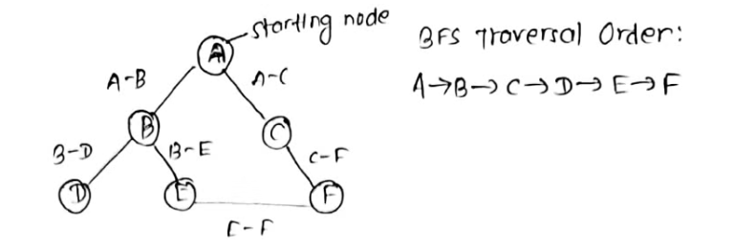

Output:
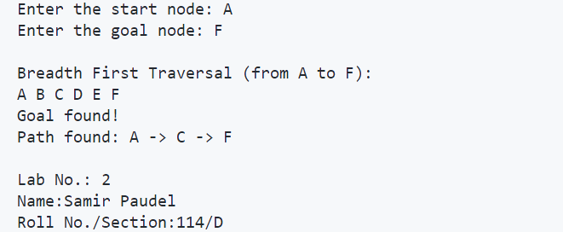

3 | Title: WAP to implement Uniform-cost search

Theory:
Uniform-cost search is a graph search algorithm that finds the lowest-cost path from a starting node to a goal node. It's similar to Breadth-First Search but uses a priority queue instead of a regular queue. The priority is determined by the cumulative cost of reaching the node. Uniform-cost search is complete and optimal when the cost of each step is non-negative.

Key characteristics of Uniform-cost search:
- Optimality: It always finds the lowest-cost path to the goal.
- Completeness: It's complete if the cost of each step is non-negative.
- Time Complexity: O(b^(C*/ε)), where b is the branching factor, C* is the cost of the optimal solution, and ε is the minimum cost of an action.
- Space Complexity: O(b^(C*/ε)), as it needs to store all generated nodes.

Applications of Uniform-cost search:
Route planning in navigation systems Network routing protocols Resource allocation in systems with varying costs

Code:
import heapq
def ucs(graph, start, goal):
queue = [(0, start, [])]
visited = set()

while queue:
(cost, node, path) = heapq.heappop(queue)
if node not in visited:
visited.add(node)
path = path + [node]
print(node, end=" ")
if node == goal:
print("\\nGoal found!")
return cost, path
for neighbor, step_cost in graph[node].items():
if neighbor not in visited:
heapq.heappush(queue, (cost + step_cost, neighbor, path))
return float("inf"), []

graph = {
"A": {"B": 4, "C": 2},
"B": {"D": 3, "E": 1},
"C": {"B": 1, "D": 5},
"D": {"E": 2},
"E": {"F": 5},
"F": {},
}

start = input("Enter the start node: ")
goal = input("Enter the goal node: ")

print(f"Uniform Cost Search (from {start} to {goal}):")
cost, path = ucs(graph, start, goal)

if path:
print(f"Shortest path: {' -> '.join(path)}")
print(f"Total cost: {cost}")
else:
print("No path found")

print("\\nLab No.: 3")
print("Name: Samir Paudel")
print("Roll No./Section: 114/ D")

Graph Visualization: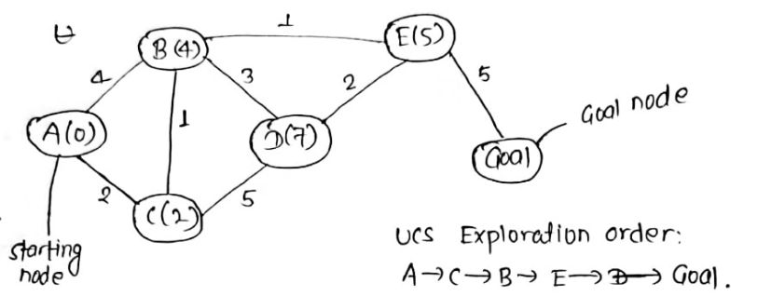

Output:

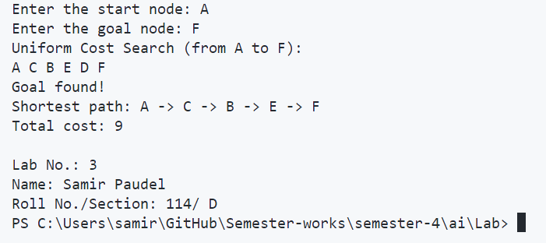

4 | Title: WAP to implement DFS for a graph

Theory:
Depth-First Search (DFS) is a graph traversal algorithm that explores as far as possible along each branch before backtracking. Unlike BFS, which uses a queue, DFS typically uses a stack (or recursion) to keep track of the nodes to be explored. DFS is often simpler to implement than BFS, but it doesn't guarantee the shortest path in an unweighted graph.

Key characteristics of DFS:
- Memory Efficiency: DFS is typically more memory-efficient than BFS, especially for deep graphs.
- Completeness: DFS is complete for finite graphs, meaning it will find a solution if one exists.
- Non-optimality: DFS does not guarantee finding the shortest path in an unweighted graph.
- Time Complexity: O(V + E), where V is the number of vertices and E is the number of edges.
- Space Complexity: O(h), where h is the maximum depth of the recursion stack.

Applications of DFS:
Topological sorting Finding connected components in a graph Maze solving algorithms Cycle detection in graphs

Code:
def dfs(graph, start, goal):
visited = set()
path = []

def dfs_helper(vertex):
visited.add(vertex)
path.append(vertex)
print(vertex, end=" ")
if vertex == goal:
print("\\nGoal found!")
return True
for neighbor in graph[vertex]:
if neighbor not in visited:
if dfs_helper(neighbor):
return True
path.pop()
return False

if dfs_helper(start):
return path
else:
return None

graph = {0: [1, 2], 1: [2], 2: [0, 3], 3: [3]}
start = int(input("Enter the start node: "))
goal = int(input("Enter the goal node: "))

print(f"Depth First Traversal (from {start} to {goal}):")
result = dfs(graph, start, goal)

if result:
print("Path found (not necessarily shortest):", ' -> '.join(map(str, result)))
else:
print("No path found")

print("\\nLab No.: 4")
print("Name: Samir Paudel")
print("Roll No./Section: 114/ D")

Graph Visualization: 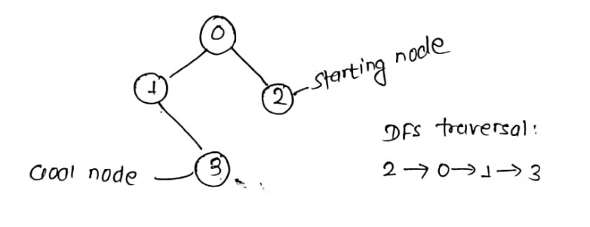

Output:

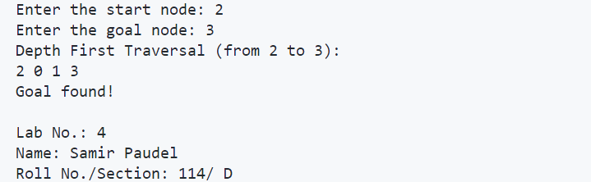

5 | Title: WAP to implement Depth limited search for a graph

Theory:
Depth Limited Search (DLS) is a variant of depth-first search where the search is limited to a maximum depth. This addresses the issue of DFS potentially getting stuck in infinite loops or very deep paths. DLS is particularly useful when we know that all solutions will be at a limited depth from the root.

Key characteristics of Depth Limited Search:
- Completeness: Complete only if the solution is within the depth limit.
- Optimality: Not optimal, as it may not find the shallowest goal state.
- Time Complexity: O(b^L), where b is the branching factor and L is the depth limit.
- Space Complexity: O(bL), linear space relative to the depth limit.

Applications of Depth Limited Search:
Game playing algorithms with a fixed number of moves, Puzzle solving with known maximum solution depth, Network routing with hop limits, Web crawling with depth restrictions

Code:
def dls(graph, start, goal, depth_limit):
def dls_util(node, goal, depth, path):
print(node, end=' ')
if node == goal:
print("\\nGoal found!")
return path
if depth == 0:
return None
for neighbor in graph[node]:
result = dls_util(neighbor, goal, depth - 1, path + [neighbor])
if result:
return result
return None
return dls_util(start, goal, depth_limit, [start])

graph = {
0: [1, 2],
1: [3, 4],
2: [5, 6],
3: [],
4: [],
5: [],
6: []
}

start = int(input("Enter the start node: "))
goal = int(input("Enter the goal node: "))
depth_limit = int(input("Enter the depth limit: "))

print(f"Depth Limited Search (from {start} to {goal}, depth limit {depth_limit}):")
result = dls(graph, start, goal, depth_limit)

if result:
print(f"Path found within depth limit {depth_limit}: {' -> '.join(map(str, result))}")
else:
print(f"No path found within depth limit {depth_limit}")

print("\\nLab No.:5")
print("Name: Samir Paudel")
print("Roll No./Section: 114 / D")

Graph Visualization:

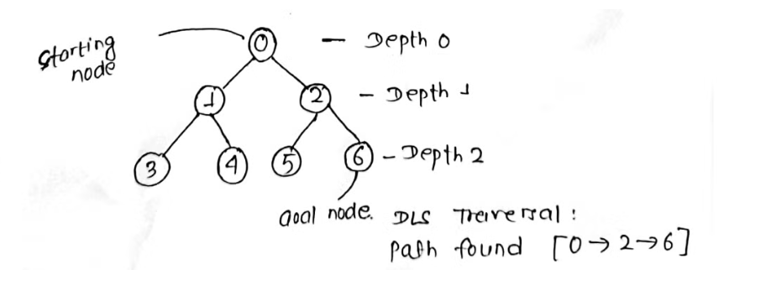

Output:

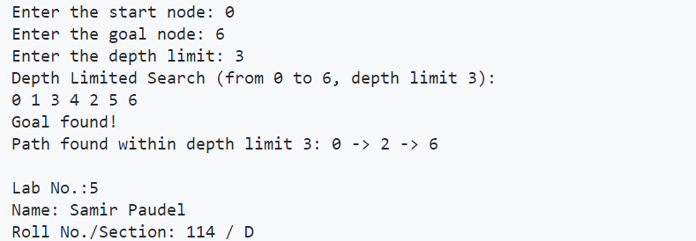

6 | Title: WAP to implement greedy best first search

Theory:
Greedy Best-First Search is an informed search algorithm that uses a heuristic function to estimate the cost from the current node to the goal. It always expands the node that appears to be closest to the goal, based on the heuristic function. While this can be very efficient, it does not guarantee the optimal solution.

Key characteristics of Greedy Best-First Search:
- Completeness: Not complete, may get stuck in loops or fail to find a solution.
- Optimality: Not optimal, as it may not find the best solution.
- Time Complexity: O(b^m) in the worst case, but often much faster in practice.
- Space Complexity: O(b^m), where b is the branching factor and m is the maximum depth of the search space.

Applications of Greedy Best-First Search:
Pathfinding in video games, Solving puzzles like the 8-puzzle or 15-puzzle, Network routing protocols, Resource allocation in constrained environments

Code:
import heapq

def best_first_search(graph, start, goal, heuristic):
queue = [(heuristic[start], start)]
visited = set()
while queue:
_, vertex = heapq.heappop(queue)
print(vertex, end=" ")
if vertex == goal:
print("\\nGoal found!")
return
if vertex not in visited:
visited.add(vertex)
for neighbor in graph[vertex]:
if neighbor not in visited:
heapq.heappush(queue, (heuristic[neighbor], neighbor))
print("\\nGoal not found!")

graph = {'A': ['B', 'C'], 'B': ['D', 'E'], 'C': ['F'], 'D': [], 'E': [], 'F': []}
heuristic = {'A': 3, 'B': 2, 'C': 1, 'D': 6, 'E': 4, 'F': 0}

start = input("Enter the start node: ")
goal = input("Enter the goal node: ")

print(f"Best First Search (from {start} to {goal}):")
best_first_search(graph, start, goal, heuristic)

print("\\nLab No.:6")
print("Name: Samir Paudel")
print("Roll No./Section: 114 / D")

Graph Visualization:
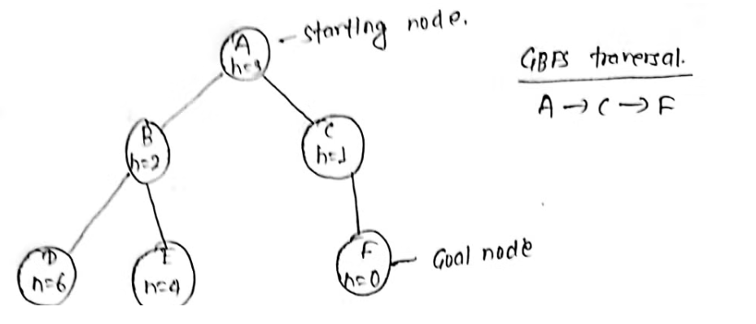

Output:

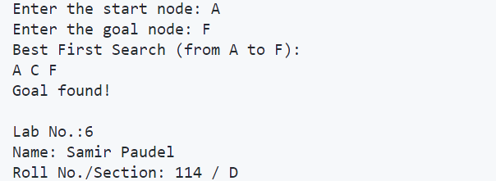

7 | Title: WAP to implement A* search

Theory:
A* (A-star) search is an informed search algorithm that combines the benefits of both Uniform Cost Search and Greedy Best-First Search. It uses a heuristic function to estimate the cost from the current node to the goal, and also considers the cost of the path from the start to the current node. A* is complete and optimal when using an admissible heuristic.

Key characteristics of A* Search:
- Completeness: Complete if the branching factor is finite and every action has a cost greater than some small positive constant.
- Optimality: Optimal if the heuristic function is admissible (never overestimates the cost to the goal).
- Time Complexity: Exponential in the worst case, but often performs much better in practice.
- Space Complexity: Exponential, as it stores all generated nodes in memory.

Applications of A* Search:
Pathfinding in maps and navigation systems, Robot motion planning, Game AI for strategy games, Network routing optimization

Code:
import heapq

def a_star_search(graph, start, goal, heuristic):
queue = [(0, start)]
costs = {start: 0}
parents = {start: None}
visited = set()

while queue:
_, vertex = heapq.heappop(queue)
if vertex == goal:
# Reconstruct the path from start to goal
path = []
while vertex:
path.append(vertex)
vertex = parents[vertex]
path.reverse()
return costs[goal], path

visited.add(vertex)
for neighbor, weight in graph[vertex]:
new_cost = costs[vertex] + weight
if neighbor not in costs or new_cost < costs[neighbor]:
costs[neighbor] = new_cost
parents[neighbor] = vertex
heapq.heappush(queue, (new_cost + heuristic[neighbor], neighbor))

# Example usage:
graph = {
'A': [('B', 1), ('C', 2)],
'B': [('D', 4), ('C', 3)],
'C': [('D', 1)],
'D': [('E', 2)],
'E': []
}
heuristic = {
'A': 6,
'B': 4,
'C': 2,
'D': 1,
'E': 0
}

cost, path = a_star_search(graph, 'A', 'E', heuristic)
print("Cost to reach goal:", cost)
print("Path:", " -> ".join(path))

print("\\nLab No.: 7")
print("Name: Samir Paudel")
print("Roll No./Section: 114/ D")

Graph Visualization: Output:

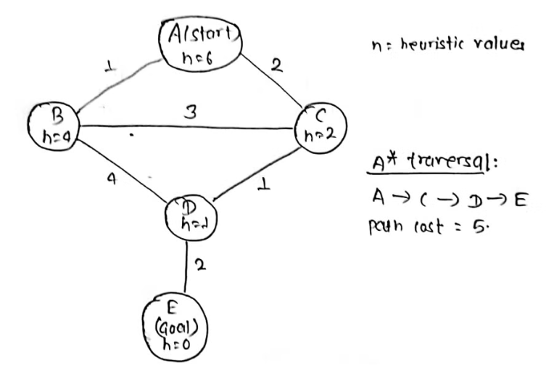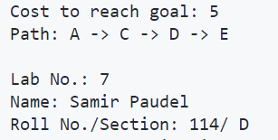

8 | Title: WAP to implement Hill Climbing (Steepest Ascent) Search

Theory:
Hill Climbing is a local search algorithm that continuously moves in the direction of increasing value to find the peak of the mountain or the best solution to the problem. The Steepest Ascent variant evaluates all neighbors and selects the one with the best value. While simple and memory-efficient, hill climbing can get stuck in local maxima.

Key characteristics of Hill Climbing (Steepest Ascent):
- Completeness: Not complete, can get stuck in local maxima.
- Optimality: Not optimal, finds local maxima but not necessarily global maxima.
- Time Complexity: O(n) in the best case, O(∞) in the worst case where n is the number of states.
- Space Complexity: O(1), as it only needs to store the current state.

Applications of Hill Climbing:
Optimization problems in machine learning (e.g., training neural networks), Job scheduling and resource allocation, Circuit design and layout optimization, Image processing and computer vision tasks

Code:
def hill_climbing(graph, start, goal, heuristic):
current = start
path = [current]

while current != goal:
neighbors = graph[current]
if not neighbors:
print("Reached a local maximum/stalemate at node:", current)
return path
next_node = min(neighbors, key=lambda n: heuristic[n], default=None)

if heuristic[next_node] >= heuristic[current]:
print("Reached a local maximum at node:", current)
return path

current = next_node
path.append(current)

print("Goal reached!")
return path

graph = {
'A': ['B', 'C'],
'B': ['D'],
'C': ['D'],
'D': ['E', 'F'],
'E': [],
'F': ['G'],
'G': []
}

heuristic = {
'A': 6,
'B': 4,
'C': 5,
'D': 3,
'E': 2,
'F': 1,
'G': 0
}

start = 'A'
goal = 'G'
path = hill_climbing(graph, start, goal, heuristic)

print("Path:", " -> ".join(path))

print("\\nLab No.:8")
print("Name: Samir Paudel")
print("Roll No./Section: 114/ D")

Graph Visualization: 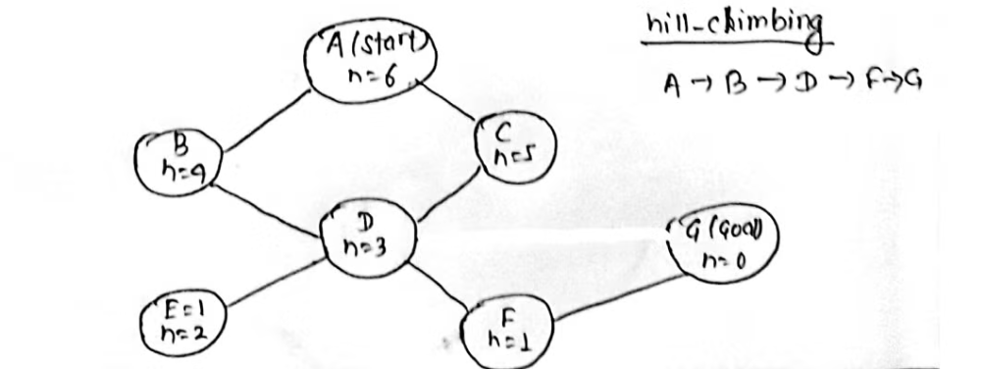

Output:

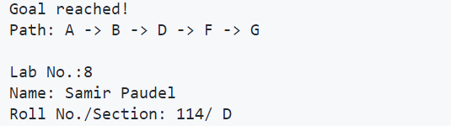

9 | Title: WAP to solve any one Cryptarithmetic Problem (like TWO + TWO = FOUR or SEND + MORE = MONEY)

Theory:
Cryptarithmetic problems are mathematical puzzles where digits are represented by letters. Each letter represents a unique digit, and the goal is to find the digit assignment that satisfies the given arithmetic equation. This implementation uses a backtracking algorithm to solve the SEND + MORE = MONEY problem.

Key characteristics of Cryptarithmetic Problem Solving:
- Completeness: Complete, as it explores all possible digit assignments.
- Optimality: Optimal, as it finds the correct solution if one exists.
- Time Complexity: O(10!) in the worst case, as there are 10! possible digit assignments.
- Space Complexity: O(n), where n is the number of unique letters in the problem.

Applications of Cryptarithmetic Problem Solving:
Puzzle solving and recreational mathematics, Code breaking and cryptography education, Constraint satisfaction problems in artificial intelligence, Logical reasoning and problem-solving skill development

Code:
def solve_cryptarithmetic():
for s in range(1, 10):
for e in range(10):
for n in range(10):
for d in range(10):
for m in range(1, 10):
for o in range(10):
for r in range(10):
for y in range(10):
if len(set([s, e, n, d, m, o, r, y])) == 8:
send = 1000 * s + 100 * e + 10 * n + d
more = 1000 * m + 100 * o + 10 * r + e
money = 10000 * m + 1000 * o +100*n+10*e + y

if send + more == money:
return {
'S': s, 'E': e, 'N': n, 'D': d,
'M': m, 'O': o, 'R': r, 'Y': y
}
return None

solution = solve_cryptarithmetic()

if solution:
print("Solution found:")
for letter, digit in solution.items():
print(f"{letter} = {digit}")

send = 1000 * solution['S'] + 100 * solution['E'] + 10 * solution['N'] + solution['D']
more = 1000 * solution['M'] + 100 * solution['O'] + 10 * solution['R'] + solution['E']
money = 10000 * solution['M'] + 1000 * solution['O'] + 100 * solution['N'] + 10 * solution['E'] + solution['Y']

print(f"\\nVerification:")
print(f" {send}")
print(f"+ {more}")
print(f"-------")
print(f" {money}")
else:
print("No solution found")

print("\\nLab No.:9")
print("Name: Samir Paudel")
print("Roll No./Section: 114/ D")

Output:

